sNCF website tutorial

Registration and posting

This document serves as a tutorial for registration and posting on the official Nobis Cura Futuri website: (https://www.sa-ncf.com/). NCF members are required to have an activated account on the NCF website in order to be officially admitted as a member. If there are still pending questions which can not be answered by this document, do not hesitate to contact us on secretary@sa-ncf.com.

Registration
Step 1:
Navigate towards the registration page on the NCF website:
(https://www.sa-ncf.com/register/)
This page can also be accessed by clicking on the “Register” button at the top right corner of the front page of the NCF website.

Figure 1: Registration page top.

Step 2:
Fill in your information which is requested on this page and click the green “Register” button at the bottom of the page. The privacy policy towards which you must agree to register can be found as a downloadable file at the top of the page under the heading “Privacy_Policy_[date]”, which is also displayed in figure 1.
Note: When choosing an username do not include spaces (“ ”) in this form since this causes trouble with the validation link of your email due to the nature of the plugin used for this validation. You can however use underscores (“_”) as a word separator.
Step 3:
After completing adding your information the following message will be shown:

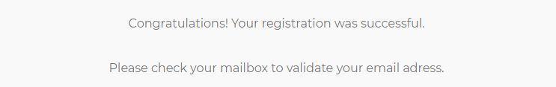
Figure 2: Message after filling in information.

Please access your mailbox and click the validation link:

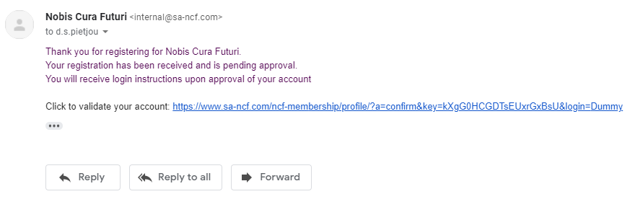
Figure 3: Validation email after registration
Step 4:
After a successful validation you will be directed towards the following message:

Figure 4: Message after successful validation of email address.

And receive the following email:

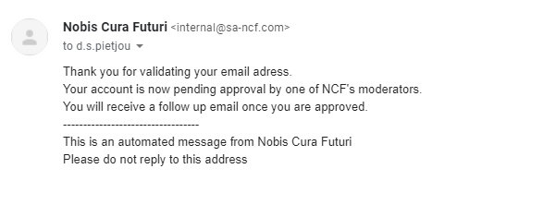
Figure 5: Email after successful validation of email address.

In order to fully access your account a NCF moderator has to manually activate your account from the back-end of the website.
Note: If the validation for some reason indicates that the URL has expired, and you clicked the link within 6 hours after receiving the email, please contact secretary@sa-ncf.com. Keep in mind that you should not use any spaces (“ ”) in your Username for the registration to avoid this particular problem.

Step 5:
After a moderator has activated your account you will receive the following email with your username, password and links towards the login page and original registration page.

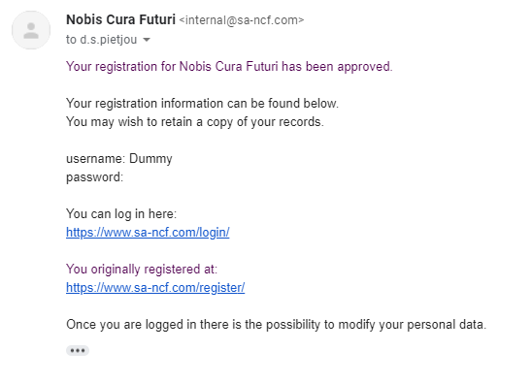
Figure 6: Email after activation of your account by moderator.

Note: After you successfully logged in with your login details on the website you can always access (https://www.sa-ncf.com/ncf-membership/profile/) to change your provided personal data.

Step 6:
You can login at the link provided in the email (https://www.sa-ncf.com/login/). Beneath the login button you can also reset your password if you forgot it. If this process seems to fail you can always contact us on secretary@sa-ncf.com.

Figure 7: login page.

Step 7:
Once logged in to the website all News events will be accessible and you can access and extra tab labelled “NCF Membership” next to the “Association” tab (figure 8). The following sublabels are accessible:
- Important documents
- Internships
- Profile
- Proof of Membership
Figure 8: NCF member exclusive tab

Posting
In order to be able to post towards the NCF website you should have the following:
- An activated account on the website
- Authorisation to add to posts on our website on this account
Note: If you believe you are eligible to create posts for NCF (f.e. Public Relations representatives) send an email to secretary@sa-ncf.com containing the details of the account you want authorised to gain access.

Step 1:
Login with the authorised NCF account on: (https://www.sa-ncf.com/beheer/).
Step 2:
Navigate in the left menu towards “Posts” and select “Add New” to create a new post. To access or edit already existing posts you can simply navigate to “All Posts” and select the posts which you want to edit.
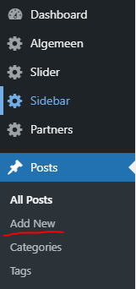
Figure 9: Posts tab extended in the left menu.

Step 3:
This provides you with the page which you can consider as the canvas of how the posts will be portrayed. You can apply the wide variety of tools offered by WordPress to make your posts as beautiful and informative as you desire, be creative!
In order to preview your posts before actually posting it navigate to “Preview” on the top right corner and click “Preview in new tab” to get an idea of how the rendered version on the website will look like.
Figure 10: Tab for previewing post in rendered setting.

Step 4:
There are drop down menu’s for the personalisation of your posts, these are the most relevant one’s for us:
- Status & visibility
- Categories
- Featured Image
- Post Restriction
- Event Date

Status & visibility
“Visibility” offers the option to password protect the access of the posts once it is published. Further restriction will be elaborated upon under “Port restriction”. At “Publish” you can set a date when the posts should be published with the standard set at “immediately”. Do not check “Stick to top of the blog” to keep a fair order of publication for each post. At this tab you can possibly delete the post by clicking “Move to trash”, after which the post is still accessible for a limited period of time.
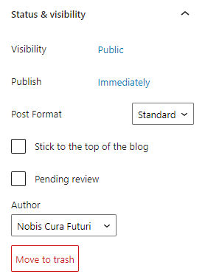
Figure 11: Status and visibility tab.

Categories
Here you can select the categories which apply towards your post, each category is has according to the location where the posts will be shown. “News” is the archive of all events. Hence I recommend you to always check this box in order to archive your post.
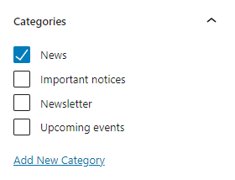
Figure 12: Categories tab.

Featured image
At this tab you can upload your own image, or chose an existing one, which will be shown together with the title of the post in the archive. Additionally, this image is shown at the top of the post.
Figure 13: Featured image tab.

Port restriction
Here you can alter access to your posts in the following ways:
Unblocked: Everyone can access the contents of the posts.
Blocked: Only activated NCF accounts, i.o.w. members, can access the post.
Hidden: The posts are hidden on the website but accessible on the back-end.

Note: If you use sign-up links in your post which are only meant for members we strongly recommend to choose the “Blocked” setting.
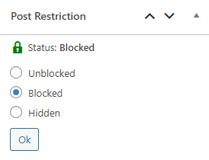
Figure 14: Post restriction tab.

Event date
The date of the event as it should be seen at the home page can be submitted underneath this tab. Figure 15 provides an example of how the format should look like.
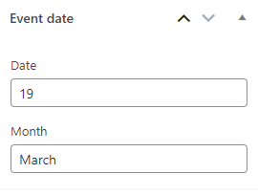
Figure 15: Event date tab.

Step 5:
When you are completely satisfied with your post you can publish it at the given time preference by clicking the blue “Publish” button on the top right corner of your screen. When you are editing a page you can click this same button (then named “Update”) in order to send all the information towards the website.
Figure 16: Publish button in top-right corner.

Dear Nobis Cura Futuri member,

We sincerely hope this document assisted well in either registration, posting or administering our website. Keep in mind that all information you provide, also who posted what, is accessible information for administrators in accordance with the privacy policy. It follows that we assume that you utilize this information in a responsible manner. Furthermore, if you encountered any trouble during any of these steps, do not hesitate to contact us on secretary@sa-ncf.com. Thank you for being an active member of our wonderful association.

Kindest regards,

Duco Pietjou
On behalf of

The NCF Board of 2020-2021

